Managing Your Opportunities
  - Help Guide for Businesses and Other Organisations
Contents
About This Guide 2
Log In 2
Manage Your Opportunities 3
Send Opportunities to Permitted Users 5
Search Organisations 8
View Opportunities 10
View Organisations 11
Add Contact 12
Edit Contact 14
Edit Organisation Details 16
Submit Logo 18
Submit Feedback 20
Change Password 21
Log Out 23

About This Guide
- This guide is intended to assist businesses and other organisations in managing the work placement opportunities that they have registered on the New Colombo Plan Internship and Mentorship Network website. Registered host organisations can update and add new opportunities at any time.

Log In
- On the main page, enter your email address and password.
- Click Log In to log in to the website.
If you have forgotten your password,
- Click Forgotten your password?
- Enter your email address.
A temporary password will be sent to you.
If you have any trouble accessing this website please contact the NCP Secretariat at ncp.business@dfat.gov.au or phone +612 6261 9840.

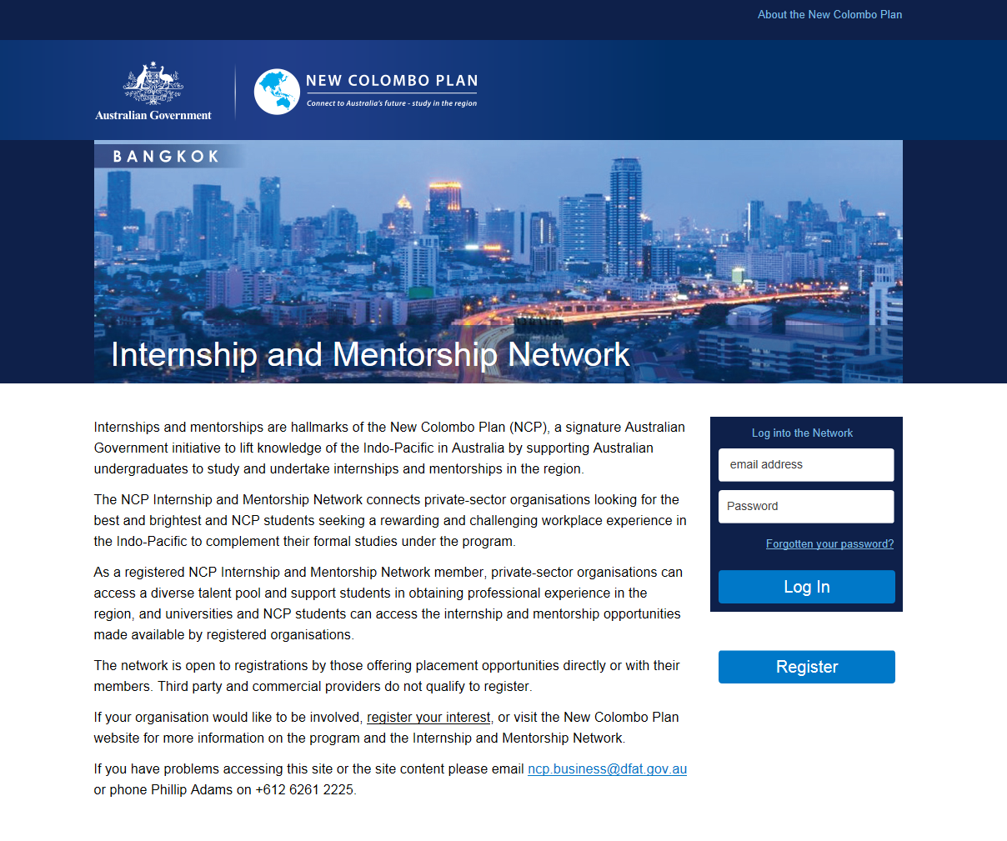

Manage Your Opportunities
Once you have logged into the website, you can locate your opportunities through the search function or via the My Opportunities tab. Your search criteria may be a combination of keywords, search fields or a date range.
- If you use the search function to locate your opportunities, enter one or more keywords.
- Select a value from the drop-down menu of the search fields.
- Enter a date range.
- Click Search.

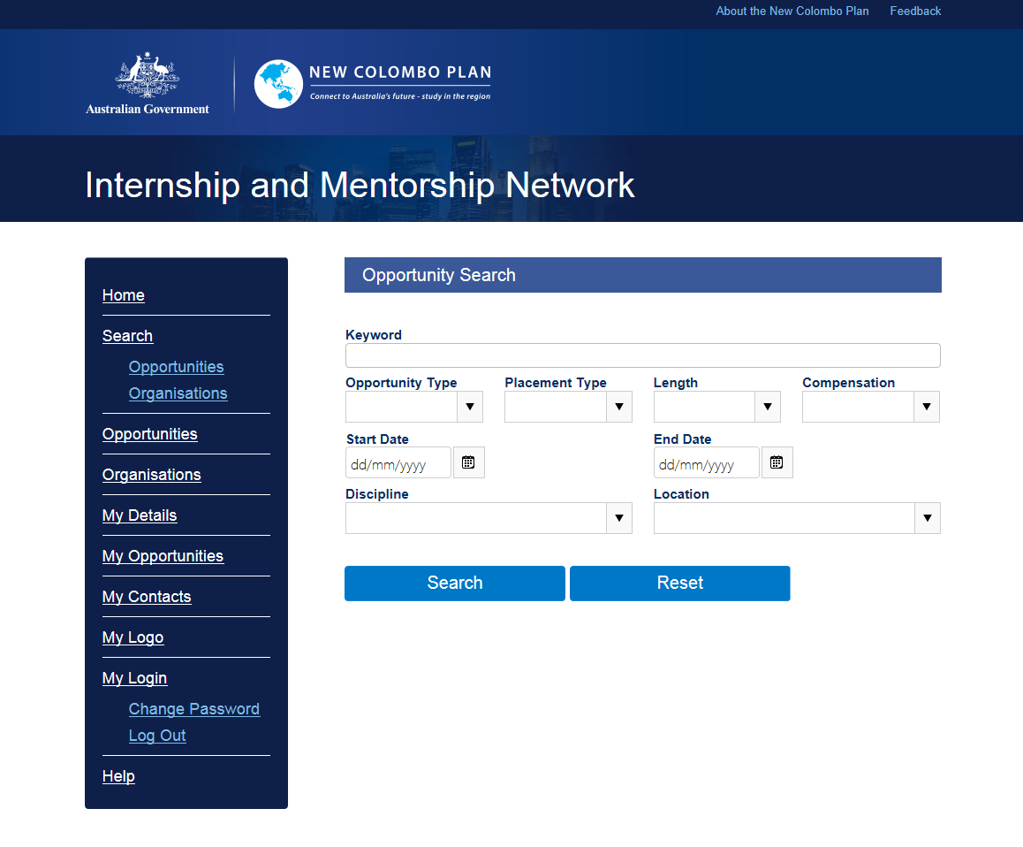
– Search opportunities
- Click the view icon to view additional details.
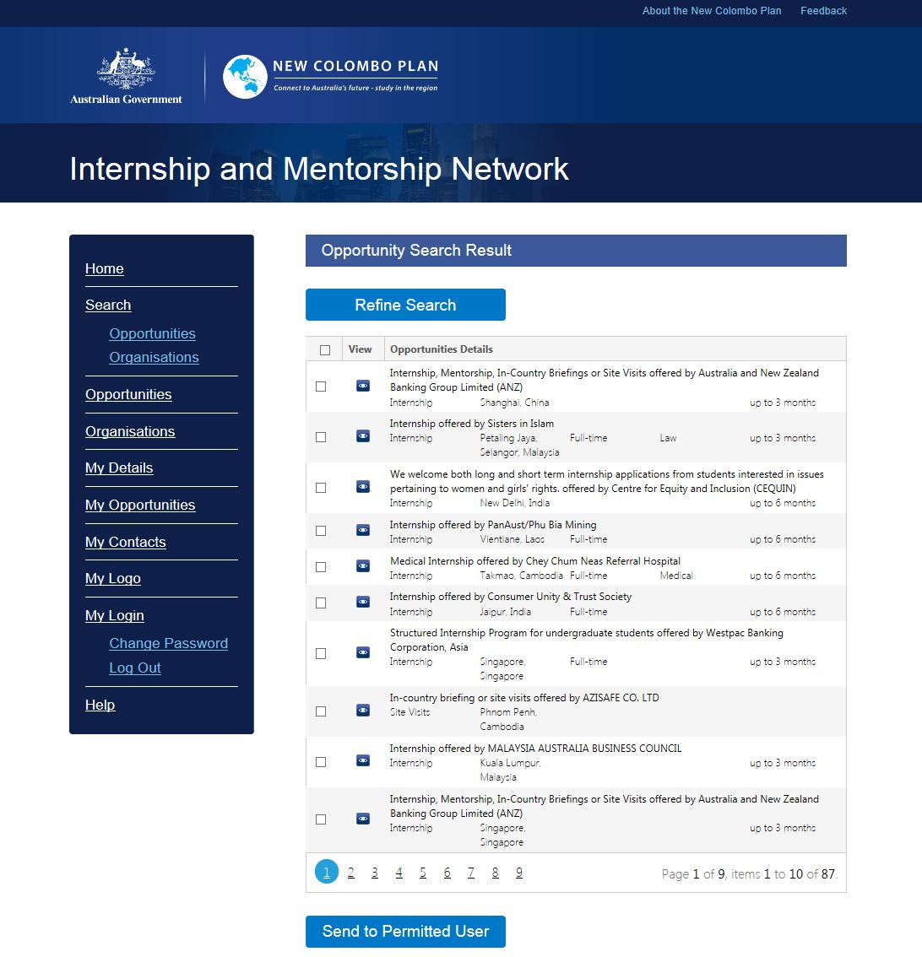
– Change search criteria

Send Opportunities to Permitted Users
You may wish to send opportunity data to permitted users where the data is being forwarded for the purposes of managing information about your Organisation and Opportunities that you make available via the website. For example, a registered organisation contact person can forward opportunities to a colleague within their organisation for updating. To do this, perform a search of opportunities or go to My Opportunities. From the search results, you may select one or more opportunities to send.
- Select one or more opportunities.
- Click Send to Third Party.

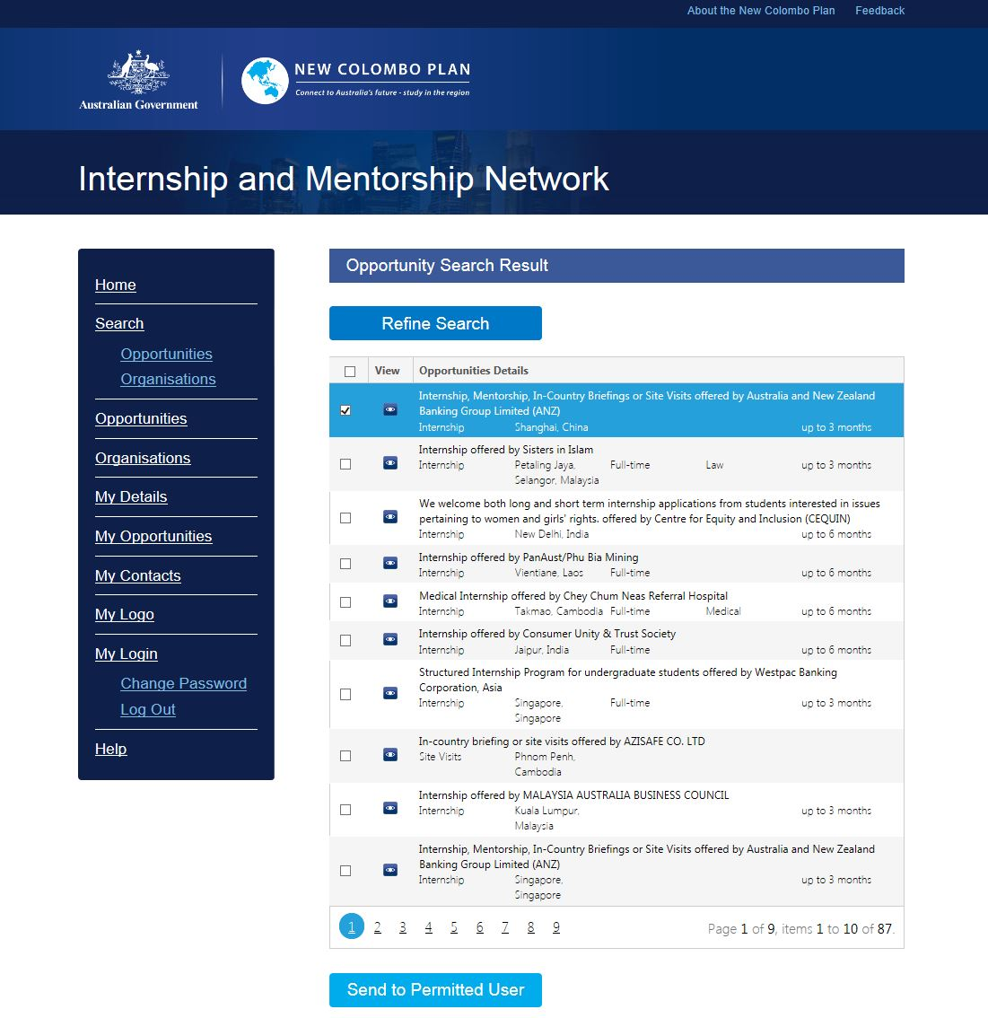
– Send to permitted user
- Enter one or more destination email addresses.
- Enter a subject.
- Enter your desired text into the Body section.
- Read and accept the terms of use.
- Click Send.
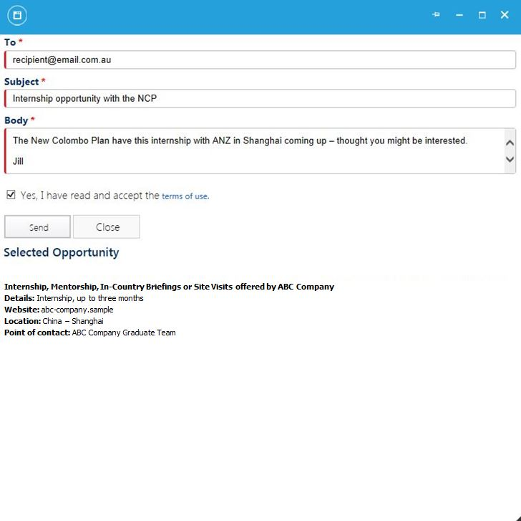
– Send opportunities
- When you are viewing data under My Opportunities, you may send that information to a permitted user.
- Click Send to Permitted User.
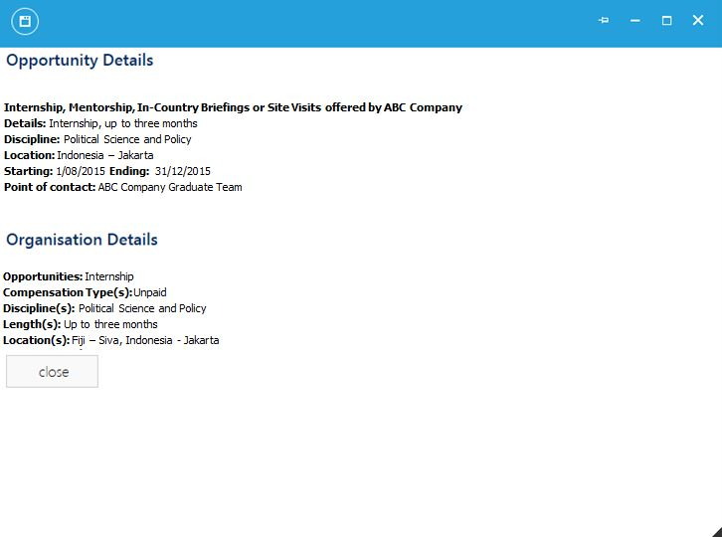
– Send to permitted user

Search Organisations
You can view internship/mentorship opportunities offered by other organisations by entering your search criteria. Your search criteria may be a combination of keywords, search fields or a date range. To search specific opportunities, use Search Opportunities.
- Enter one or more keywords.
- Select a value from the drop-down menu of the search fields.
- Enter a date range.
- Click Search.

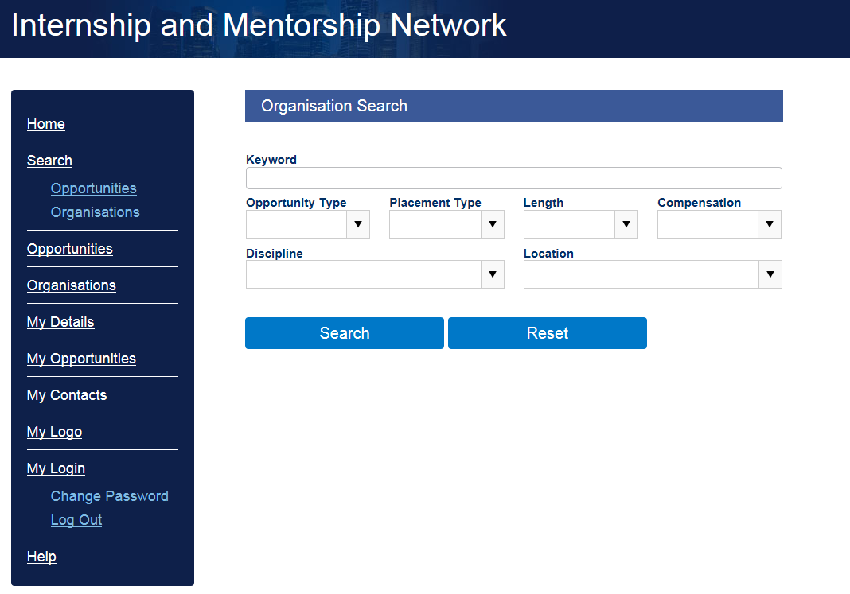
– Search organisations
- Click the view icon to view additional details.
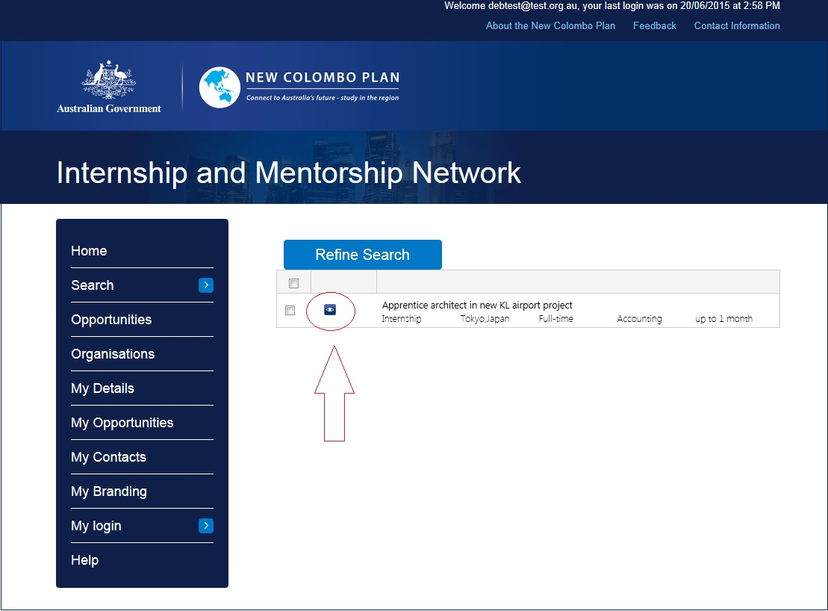
– Change search criteria

View Opportunities
You can view specific opportunities offered by other organisations. Opportunities are continuously updated and we encourage you to visit this page regularly.
- From the menu, click Organisations.
- Click the page numbers to page through the listing.

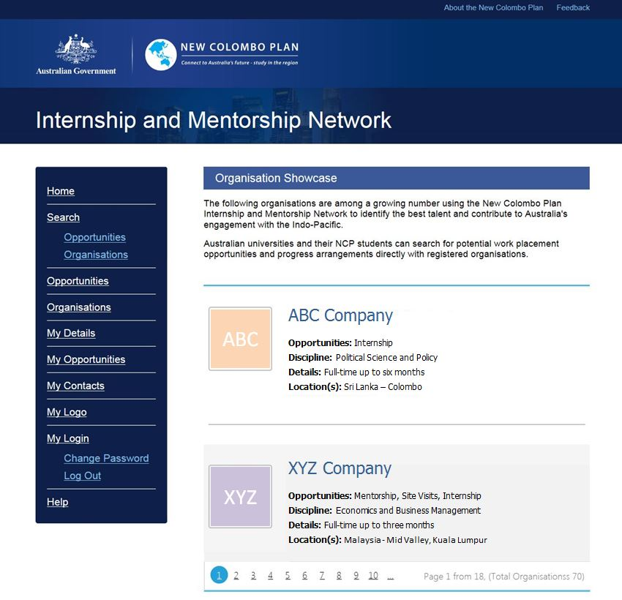

View Organisations
Host Organisations continuously update placement opportunities and we encourage you to visit this page regularly.
- From the menu, click Organisations.
- Click the page numbers to page through the listing.

Add Contact
You can add or update your contact details to enable Australian universities and students to contact your organisation directly to enquire about the opportunities that you make available via the website.
If a new contact requires access to the website, they will receive a separate email with login instructions.
- Click Add Contact.

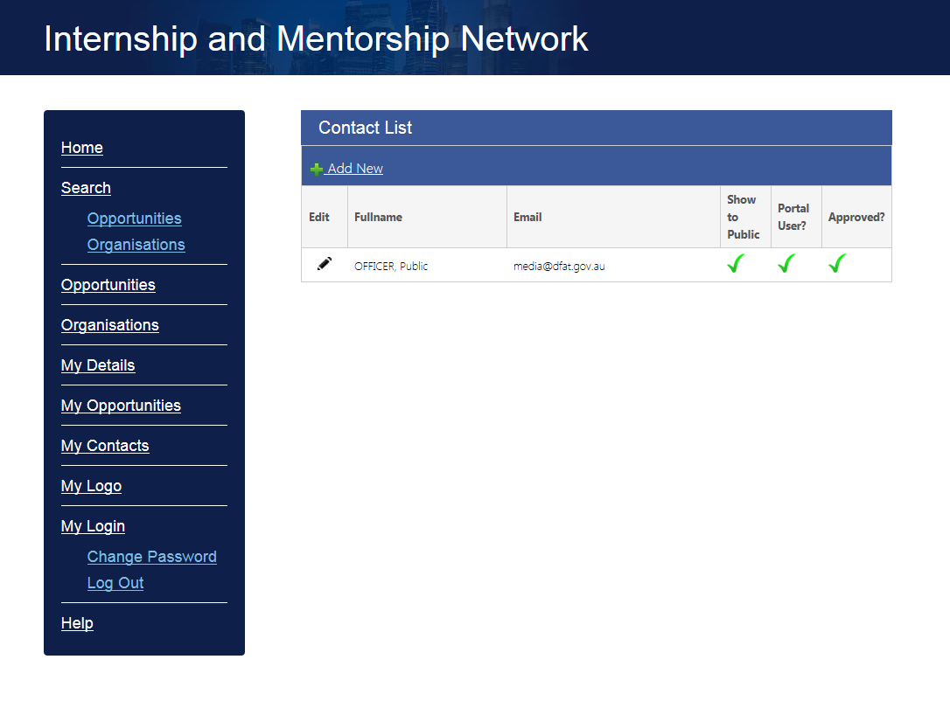
- Enter first name and last name.
- Enter email address. This will be used to log in to the website and cannot be modified.
- Enter position.
- If this contact requires access to the website, check “Does this contact require a portal account?”
- Click Save when done.
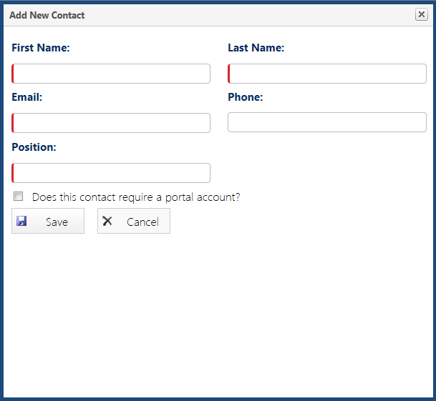

Edit Contact
You can edit details of existing contacts. Note: Email addresses cannot be modified because they are used to log in to the website.
- Click edit icon

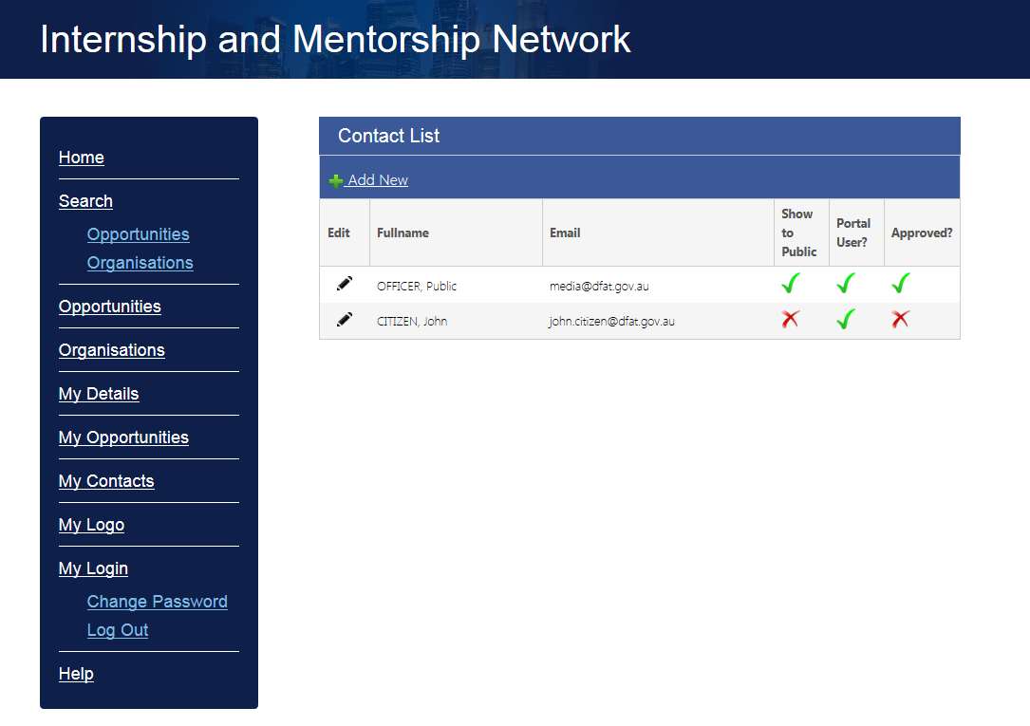
- Make the required changes.
- Click Save when done.
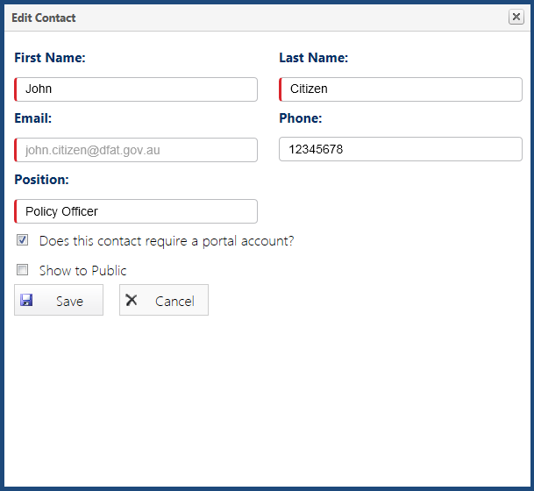

Edit Organisation Details
You can make changes to details you have provided about your organisation.
- From the menu, click My Details.

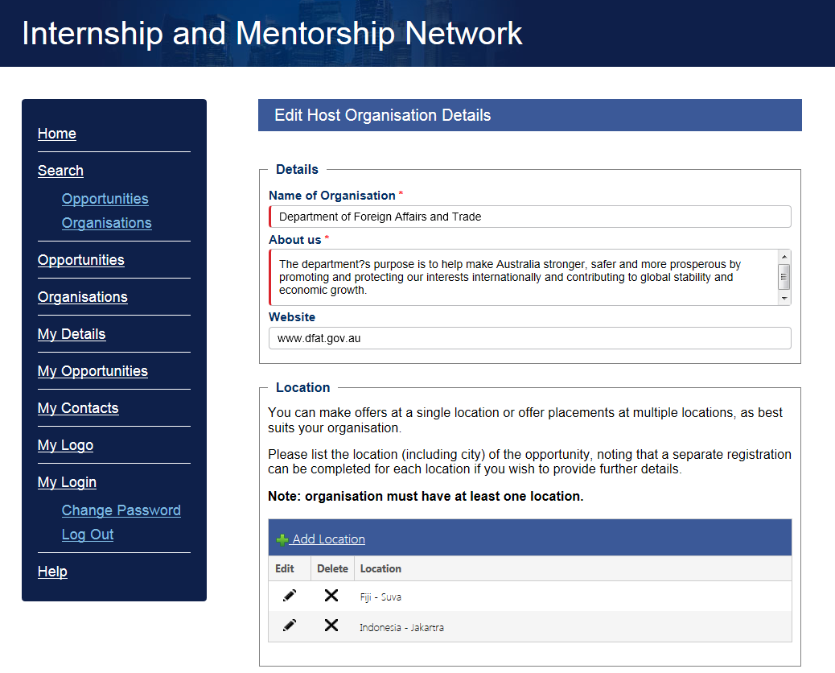
- Make the necessary changes.
- Scroll to the bottom of the page.
- Click Save when done.
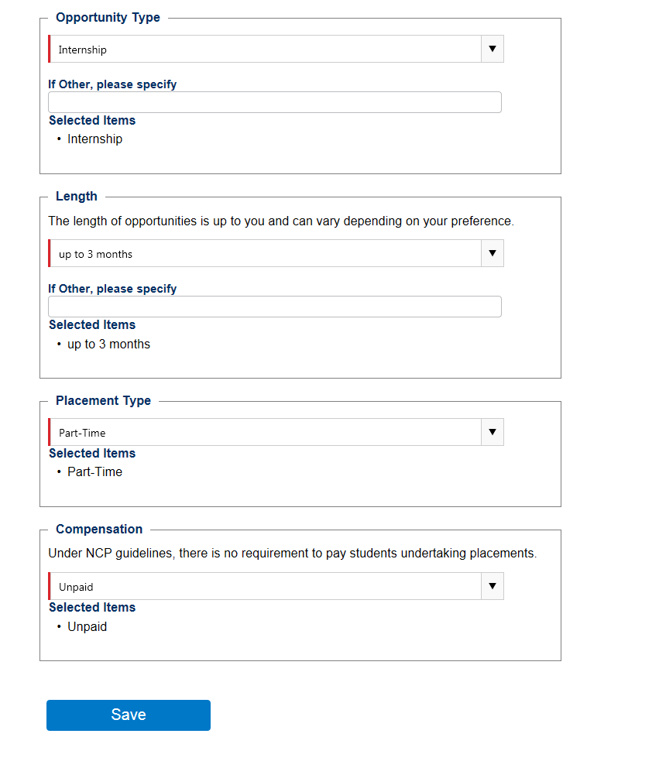
– Save changes

Submit Logo
You can submit your logo to the website to appear alongside your opportunity data. By submitting your logo to the website, you grant the New Colombo Plan Secretariat the right to publish the logo on the website. If you do not submit your logo, the New Colombo Plan logo will appear in its place.
The logo that you submit will be processed by the New Colombo Plan prior to publication.
- From the menu, click My Logo.
- Click Upload Image.
- Select the image file to upload.
- Click Open.

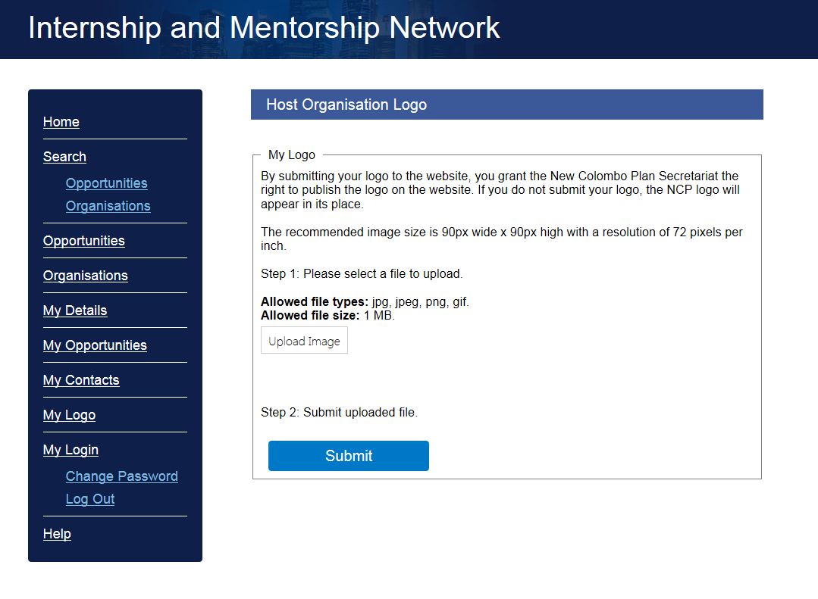
- Ensure the image file is uploaded.
- Click Submit.
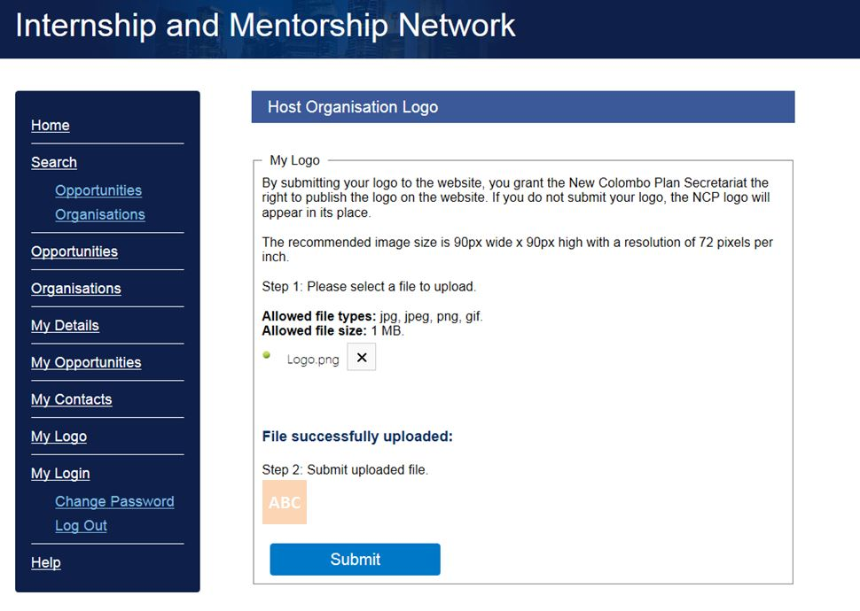
– Submit logo

Submit Feedback
Your feedback on the website is valuable. You can provide feedback on your experience via the Feedback link at the top of the page. You may request a response to a specific question and leave contact details so that the NCP Secretariat can get back to you.
- Click Feedback on the top header.
Then
- Select feedback category.
- Enter your feedback subject.
- Enter details of your feedback.
- Indicate if you would like a response.
- Click Submit Feedback.

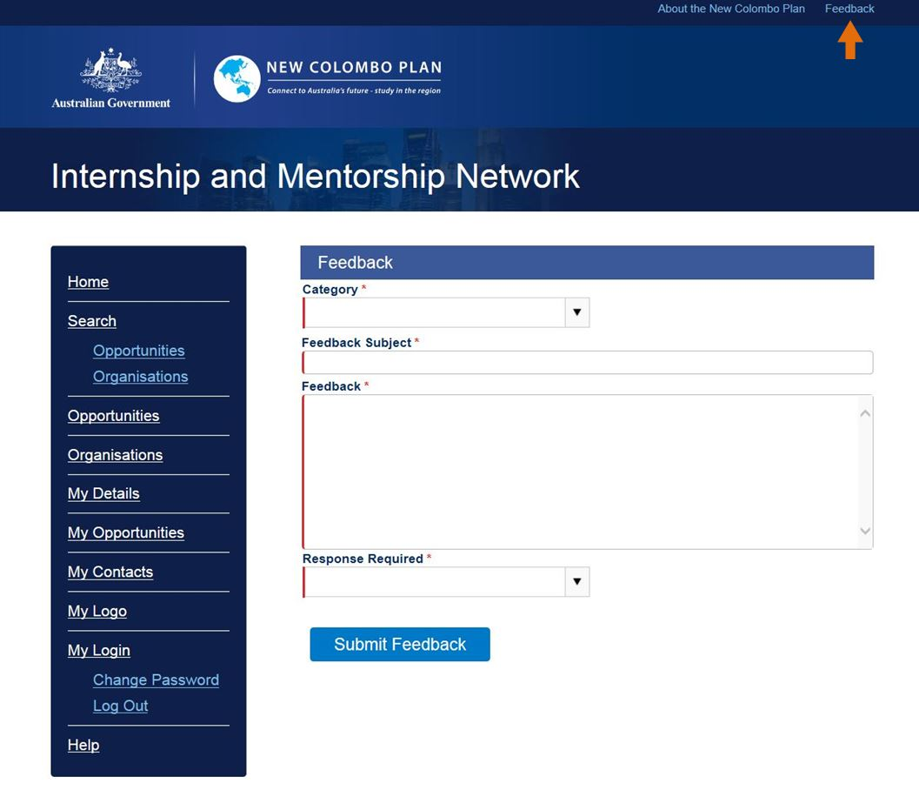

– Submit feedback

Change Password
- From the menu, click Change Password.

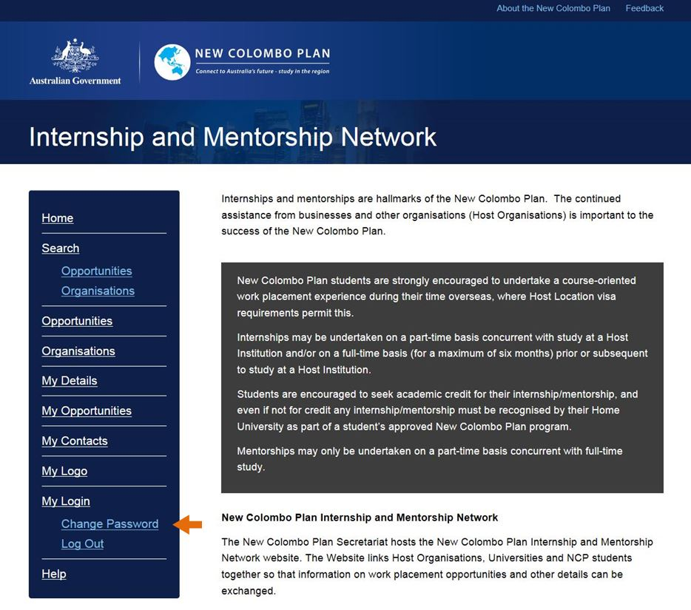
- Enter your current password.
- Provide and confirm your new password.
- Click Submit.
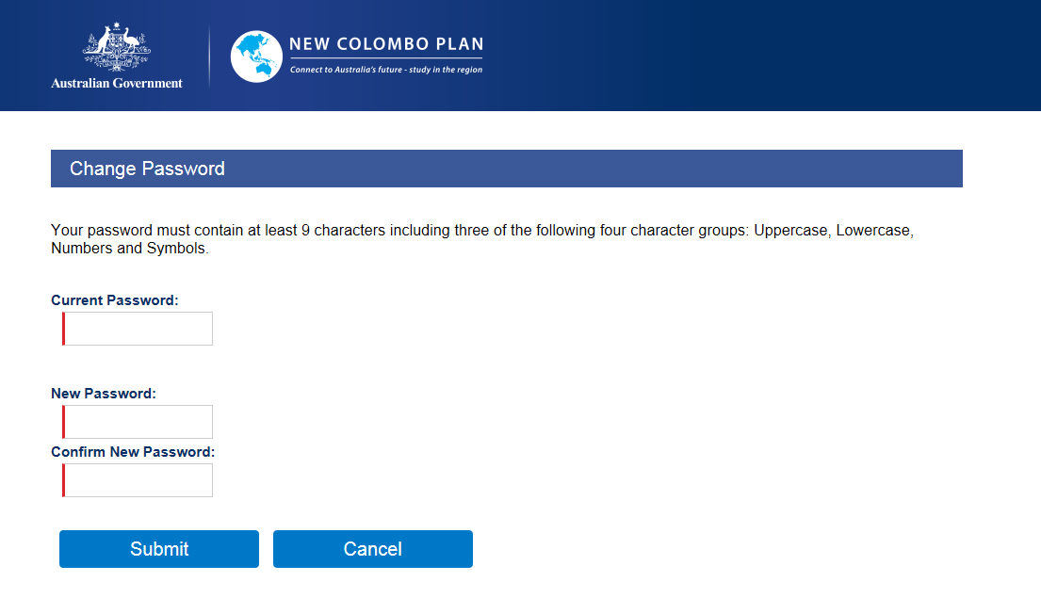
– Submit new password

Log Out
- Click Log Out.

